**COLLEGE BITES: A WEB PLATFORM FOR CANTEEN MANAGEMENT**

Sahil Baviskar1, Kshitija Deshmukh2, Lokesh Deshmukh3, Nishica Kothawade5

Department of Computer Engineering, Vishwakarma Institute of Information Technology, India1,2,3,4

Mail1 : [sahil.22210750@viit.ac.in](mailto:sahil.22210750@viit.ac.in)1

Mail2 : [kshitija.22210574@viit.ac.in](mailto:kshitija.22210574@viit.ac.in)2

Mail3 : [lokesh.22210755@viit.ac.in](mailto:lokesh.22210755@viit.ac.in)3

Mail4 : [nishica.22210402@viit.ac.in](mailto:nishica.22210402@viit.ac.in)4

# ABSTRACT

This paper discusses the idea, creation, and use of a website to manage a college canteen. The website is designed to make it easier for students and staff to order food. The website allows users to log in, choose from a variety of menu items, customize their orders, and pay for their meals online. It also lets users order food in advance, so they don't have to worry about time to sit during busy times. We've built this website using the latest web technologies to ensure it works smoothly. It can handle a lot of users at once, and it's secure to protect your information and payments. This website can help reduce long lines at the canteen place food online, make sure you have a seat when you need it, and provide a better overall dining experience without worrying about time. It's designed to work well for a lot of people, making it a useful tool for a busy college canteen.

**Keywords:** Time flexibility, Canteen menu, instant food availability.

# INTRODUCTION

During lunch hours, there are a lot of students at both the counter and dining area. Since all students have equal lunch break, they all go to canteen simultaneously. This makes the navigation and finding of the right place very difficult for students. Due to the lack of time to eat, some students even miss some of their lectures. However, there is a solution called canteen management system. Canteen management system simplifies the entire process. Students do not have to wait in line to order their food. They can order the food ahead of time on their phones and on the website. Before ordering the food, students need to enter their email address. The kitchen staff receives a message and starts making the food immediately. All the data is stored in SQL servers which are managed by the College Bites system. The system has a logging system which keeps track of all user access and ensures that the canteen management is more efficient.

# LITERATURE SURVEY

In reference [1], In User login, you need to register first. Once you have registered, you can log in to the system using your ID and password. Once you log in, you will be able to view various menu options.

In reference [2], The user can log in and view several menu options after registering. To save time, users can select various food products by clicking the "add to cart" button, place an order, or remove any item. Following the user's order placement, they must utilise Paytm or PayUMoney to settle the bill in cash upon delivery.

In reference [3], To visualise the suggested methodology, the technological stack utilised consists of MySQL, HTML, CSS, JavaScript and Node.js. The RDBMS utilised for database management at the backend is MySQL, which is quick and simple to use.

Node.js is a runtime environment that allows you to run JavaScript code on the server-side. When combined with SQL databases like MySQL,Node.js can be used to create powerful and scalable web applications other presentation-related elements are designed into web pages using CSS, one of the foundational technologies of the World Wide Web, in conjunction with HTML and JavaScript.

In reference [4], The standard markup language for documents intended for web browser display is called Hypertext Markup Language, or HTML. HTML provided signals for the document's design and provides a semantic description of a web page's structure. client-side scripting is done using the JavaScript (JS) programming language, which is short for ECMAScript specification.

In reference [5], The main benefit of online ordering is that it makes the ordering process as simple as possible for the customer and canteen. When the customer goes to the ordering website, they see an interactive and real-time menu with all the available options and price changes based on the options they have chosen.

In reference [6], Huge crowd during peak hours at IT sector and factory to overcome this, a solution of online food ordering in particular café using web application. Register on website and place their food in peak hours and pay online. Time spent on queue reduced.

# METHODOLOGY

Students and faculty members who use College Bites will have access to the following features:

+ Open a user account.

+Register on the website

+ Click on the item in the menu.

+ Include a new item in an existing order.

+ Cancel any item.

+ Choose the table based on what is needed.

+ Give your payment information,

+ Log off the device.

Enrolment:

The user must first create an account on the website using their email address and password.

Order Submission:

The user will receive an E-menu card after registering, on which he can choose the meal items.

Arrangement:

Here, the chef verifies the order and notifies the owner. The owner is informed of the hill transactions and verifies the payment's success.

Final Order:

Deliveries of the confirmed order follow successful payment.

**ER Diagram**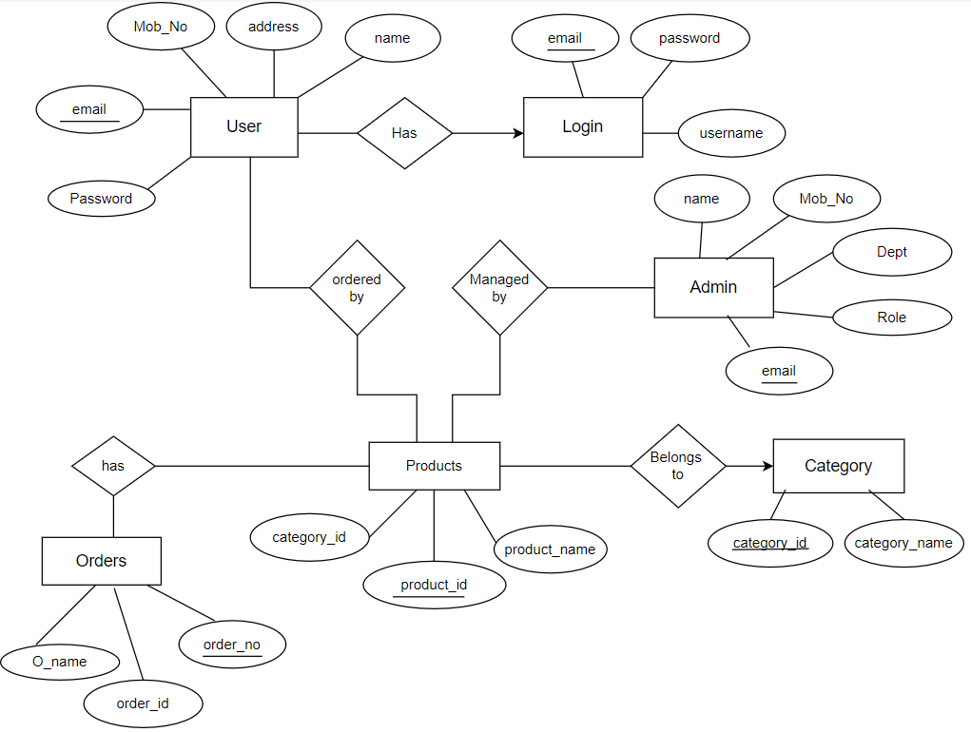

# APPLICATIONS

The canteen management website can find application in various contexts, including:

Academic Establishments: It can be utilized at colleges, universities, and schools to expedite the food service operations in the canteens.

Corporate Cafeterias: Big office buildings or corporate campuses can use this type of site to oversee cafeteria operations, making sure that workers can order and get food.

Hospitals: This website can help hospitals provide better meal services for their patients, guests, and employees by cutting down on wait times and making ordering and delivery of food easier.

Chain Restaurants: To make it easier for consumers to place orders, and shorten wait times, chain restaurants can include comparable functions into their websites.

In addition to canteens, the technology and functionality created for these websites can be applied to more general meal delivery services, enabling users to effectively make orders and follow deliveries. Any environment where food service is offered and there is a desire to boost customer happiness, speed up the eating experience, and reduce wait times can benefit from the use of a canteen management website.

# RESULT

Efficient Order Placement: Users have embraced the convenience of placing orders through the website, reducing queues at the counter, and expediting the ordering process.

Optimized Order Delivery: The integration of the site with the canteen's kitchen has led to faster and more accurate food preparation, resulting in reduced wait times for customers.

Payment Options: The inclusion of multiple payment options has streamlined transactions, reducing payment times and errors.

Crowd Management: Users have benefited from features such as peak-hour alerts and crowd tracking, enabling them to make informed decisions about when to visit the canteen.

Feedback and Improvement: Continuous feedback collection and analysis have allowed the canteen management to make data-driven improvements, further enhancing the user experience.

# 

# CONCLUSION

Our website for managing the canteen effectively increases productivity, comfort, and user happiness. The eating experience has been enhanced by features including prompt orders, attentive service. It is an excellent illustration of how to improve the efficiency of food service in a variety of settings, including cafeterias, hospitals, and campuses. We will create longer more reliable databases in the future to retrieve records. We'll also try to provide the greatest services and online payment alternatives.

We'll try to update the student and admin accounts later. There will be additional interesting features added to make it even more helpful for kids.

# REFERENCES

[1] Ketan Bhekare, Chinmay Karandikar, Ganesh Kamble, Prof. Varsha Wangikar, “Smart Canteen System”, Journal of Emerging Technologies and Innovative Research, JETIR, Volume 6, Issue 4, April 2019

[2] G.Sanjana Reddy, “Canteen Management System”, International Journal Of Engineering Research and Technology (IJERT), ISSN:2278-0181, DOI: 10.17577/IJERTV12IS040301, Volume 12, Issue 04, April 2023

[3] Marko Kukanja, Tanja Planinc, Tadeja Jere Jakulin, “Research Managers’ Perceptions of Service Quality: The Mediating Role of Restaurant Size and Seating Capacity”, International Journal for Quality Research 14(1) 237-252 ISSN 1800-6450, DOI- 10.24874/IJQR14.01-15, 2019

[4] Nikhil Sahani, Darshan Kadam, Atharva Kulkarni, Saurabh Shahapure, Prof. Tejal Shinde, “Canteen Automation System using Android”, International Journal of Innovative Research in Technology, IJIRT, Volume 5 Issue 8, ISSN: 2349-6002, January 2019

[5] Shourya Pradhan, Shubhanshu Pratap Singh, Shubham Jain, Yash Gupta, “Canteen Management App”, International Journal of Information Sciences and Application (IJISA), International Research Publication House, ISSN 0974-2255, Vol.11, No.1, 2019

[6] Lalitha V, Magesh K, Selvarayanan A, Keertheshwaran G, “E-Canteen Management System based on Web Application”, 2022 International Conference on Communication, Computing and Internet of Things (IC3IoT), IEEE, DOI-10.1109/IC3IOT53935.2022.9767984